Chapter 4, Problem 75.

For the circuit in Fig. 4.141, determine the value of R such that the maximum power delivered to the load is 3 mW.

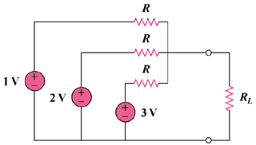

Figure 4.141
For Prob. 4.75.

